Exploring the Redox Chemistry of Chromium Through the Synthesis and Reaction of Chromium(II) Acetate

Jasmine Huang, Jason Perez (partner)

ABSTRACT: Chromium, which derives its name from the Greek chroma meaning color, is a transition metal that forms many different brightly colored coordinate complexes, and thus is an exciting element to investigate in the laboratory. In this experiment, we explore the various oxidation states of chromium by performing reductions from potassium dichromate (Cr6+) to chromic chloride (Cr3+) to chromous chloride (Cr2+) in our synthesis of chromium(II) acetate. We then exploit chromium(II) acetate’s oxidation potential to reduce elemental iodine. We also perform oxidations on known, commercially available chromium compounds, chromium(III) sulfate and potassium chromate, in varying pH environments. We analyze the products utilizing UV-Vis absorbance and correlating the findings to the chromium Pourbaix diagram to determine the final oxidation states of our compounds.

Introduction

Chromium is a transitional metal that forms various intensely colored compounds in its several oxidation states, +1, +2, +3, +4, +5, +6, with the +2, +3, and +6 forms being the most stable. Chromium (II) is readily oxidized to chromium (III) by O2 in air as indicated by the positive oxidation potential

Therefore, Cr(II) compounds must be protected from air during reactions; this can be accomplished using dry ice (CO2 (s)), when the dry ice is placed in a solution, the gaseous CO2 will displace any oxygen dissolved in the solution and the excess CO2 will eventually evolve out of solution, saturating the local atmosphere of the solution with CO2.

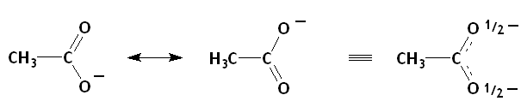

Figure 1: Structure of acetate, a bidentate ligand. The negative charge on one of the oxygen atoms is delocalized across the carboxylate group through resonance, giving each oxygen a partially negative charge.

In this experiment, we synthesize chromium (II) acetate, Cr2(O2CCH3)4(H2O)2, abbreviatedCr2(OAc)4(H2O)2, a dimeric stable chromium (II) complex. Each acetate (OAc) ligand (Fig. 1) binds to both Cr(II) centers through its partially negative oxygen atoms, the four acetate ligands are therefore called bridging ligands. Thus, each Cr(II) center is octahedral, with four OAc “monodentate” ligands, one water ligand, and the other Cr(II) center at the sixth coordination site. The complex is shown in Figure 2.

Chromium (II) acetate is an interesting compound because the short Cr-Cr bond length (195-255 pm) suggests the existence of a quadruple bond, and quadruple bonds have interesting electron transfer chemistry. The quadruple bond is formed by the efficient overlap of four of the chromium atoms’ *d* orbitals. The molecular orbitals that result due to the overlap of the individual Cr’s *d* orbitals allows for the formation of a diamagnetic compound, which means all the electrons are paired, even though each chromium(II) center has four *d* electrons. The MO diagram for the Cr—Cr bond is shown below in Figure 4. Quadruple bonds are fairly common for transition metal complexes given that the valence electrons of transition metals are in *d* orbitals, and there are five *d* orbitals (so up to five bonds between transition metals is possible ≡ quintuple bond). For example, two other transition metal complexes known to have quadruple bonds are [Re2Cl8]2- and [Mo2Cl8]4-. [Re2Cl8]2- has a square prism geometry in which the chlorine ligands are eclipsed rather than staggered which would typically be energetically favorable. It is the eclipsed alignment however, that allows for the overlap of four *d* orbitals – *dz2, dxz, dyz, dxy* – the *dx2-y2* orbitals have the appropriate symmetry to bond to the four chloride ligands. [Mo2Cl8]4- with a Mo—Mo quadruple bond also exhibits eclipsed geometry, following the reasoning given for the Re—Re quadruple bond.

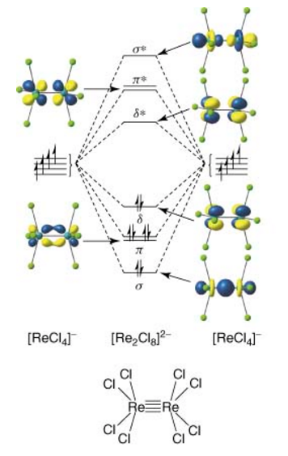

Figure 3: Schematic molecular orbital diagrams for [Re2Cl8]2- . (Mcgrady et al., 2009)

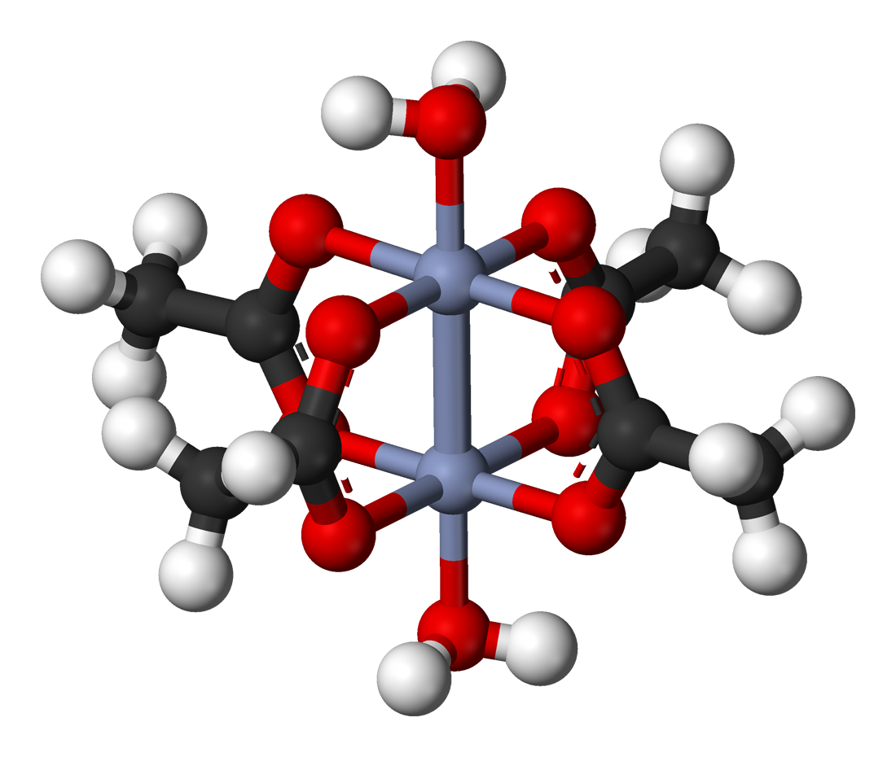

Figure 2: 3D representation of Cr2(OAc)4(H2O)2 showing the dimeric structure and bridging by acetate ligands (chromium atoms (gray), oxygen (red), carbon (black), hydrogen (white)).

Organic compounds are composed for the most part of H, C, N, O, S, F, Cl, etc. – *p*-block elements (except H). This means the atoms have valence electrons in *p* orbitals, of which there are three, meaning organic molecules can contain bond orders only up to three.

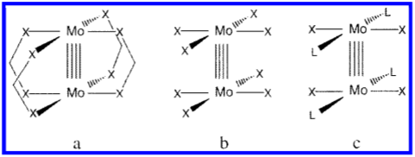

Figure 4: (a) Mo–Mo core bridged by four bidentate ligands.   
(b) Mo–Mo core coordinated by eight monodentate ligands.   
(c) Mo–Mo core coordinated by four neutral and four anionic monodentate ligands. (Cotton et al., 2002)

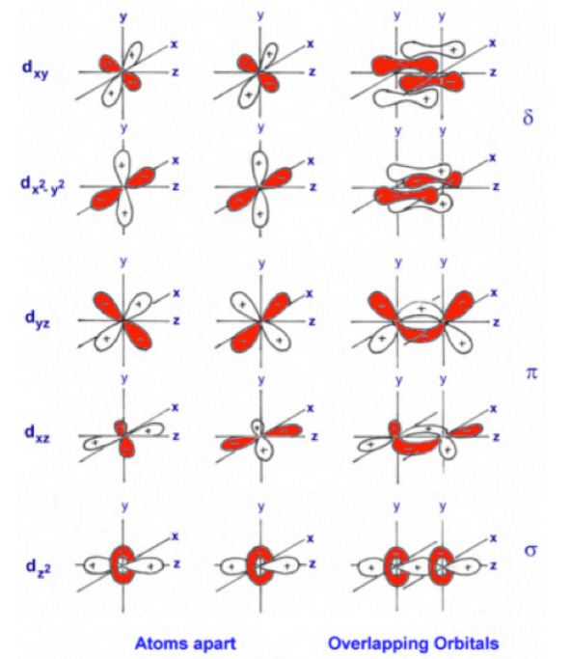Figure 6: Orientation of d-orbitals on Cr atoms aligned along the *z*-axis when the atoms are separated and when the atoms are bonded (overlapping orbitals).

We prepare red chromium (II) acetate from bright orange potassium dichromate (K2Cr2O7) which is heated with concentrated HCl, reducing the orange Cr(VI) to green Cr(III):

Then, the Cr(III) is further reduced to sky blue Cr(II) in the presence of Zn and HCl. The zinc is oxidized as it displaces hydrogen forming H2 gas:

This gas in turn reduces the green Cr(III):

Finally, the Cr(II) reacts with aqueous acetate to yield the brick red chromium(II) acetate complex:

Experimental

Part I: Preparation of Chromium(II) Acetate

The apparatus shown below was used to conduct the synthesis of chromium(II) acetate in an oxygen free environment. In a small beaker, 10 g of potassium dichromate was simmered in 50 mL of conc. HCl for 30 minutes and then cooled to room temperature. Meanwhile, in a 600 mL beaker (shown on the right in the apparatus) 50 g of sodium acetate was dissolved in 150 mL of water. Dry ice (CO2 (s)) was added to the solution to remove dissolved oxygen, and then the solution was gently simmered to fully dissolve the sodium acetate. In a 500 mL filter flask (shown on the left below), 30 g of mossy zinc was combined with the potassium dichromate solution, and 50 mL of additional conc. HCl was added portion-wise with swirling to distribute the acid. The flask was sealed immediately with a rubber stopper, and the reaction was allowed to proceed with the clip kept open to release the evolving gas. Once the solution changed to sky blue (indicating the presence of Cr2+) the clip was closed, and the solution traveled through the tubing into the beaker on the right. The chromium(II) acetate compound precipitated immediately and 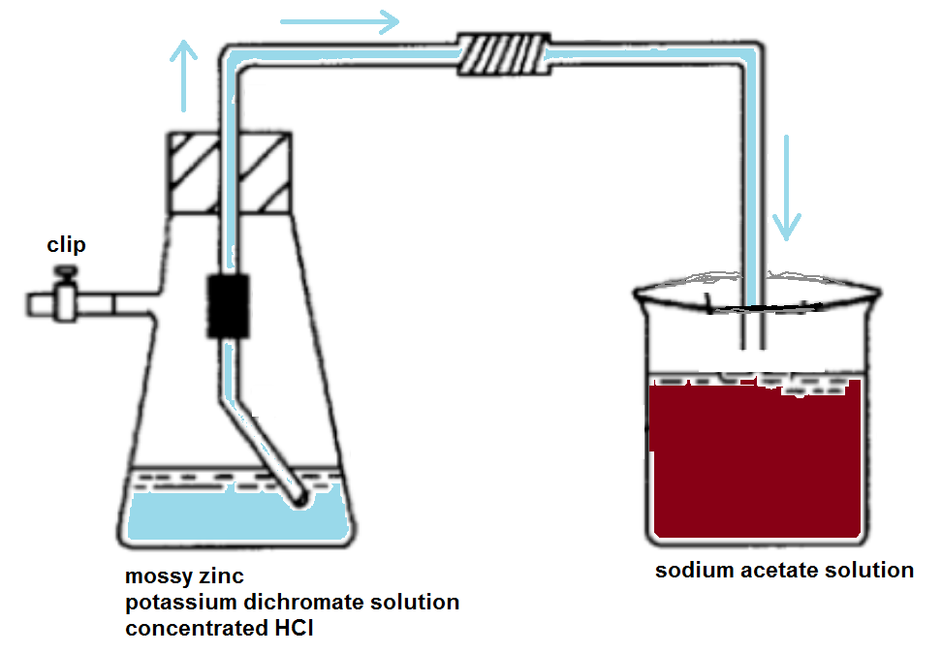a red-brown solid.

Figure 7: Experimental apparatus set-up.

The solid was separated by vacuum filtration with dry ice in the Buchner funnel during the filtration to maintain an oxygen free environment. The solid was washed with oxygen-free water (water with dry ice added) followed by a wash with acetone. The solid was stored with dry ice in a desiccator for one week. The synthesis and isolation were repeated in exactly the same manner the following week.

To characterize the compound, a weighed sample (160 mg for the first synthesis, 120 mg for the second synthesis) was dissolved in nitric acid in a 100 mL volumetric flask and the solution was diluted to 100 mL with water. A 5 mL aliquot of this solution was placed into a flask and enough 2.0M NaOH was added to neutralize the free acid. Then 10.0 mL more NaOH were added. Next, 10 drops of 30% H2O2 were added before heating on a steam bath for a few minutes until the evolution of O2 ceased. The solution was cooled to room temperature, transferred to a 250 mL volumetric flask and diluted with water to 250 mL. This reaction should have converted the Cr2+ in the product to CrO42- based on the Pourbaix diagram for chromium (Fig. 6). The absorbance spectrum of the resulting solution was collected.

Part II: Reactions of Chromium(II) Acetate with Iodine

Iodine was dissolved in CCl4 to create a dilute solution. About 1 mL of the iodine solution was transferred to a test tube and an equal volume of water was added. The solid from the first synthesis was powdered and a spatula tip full was added to the test tube. The tube was capped and shaken vigorously. The layers were allowed to separate and the color changes in the layer was observed.

Part III: Redox Chemistry of Chromium(III) Sulfate and Potassium Chromate

Chromium in chromium(III)sulfate (Cr2(SO4)3 and potassium chromate (K2CrO4) was oxidized. Two samples of 25 mg of Cr2(SO4)3 were each dissolved in 2 mL of water. The absorption spectrum of one of the samples was collected. The second solution was divided into two, 1 mL, parts. To one part 1 mL of 2 M sulfuric acid was added, to the other 1 mL 2 M sodium hydroxide solution was added. Then 1 mL hydrogen peroxide (6% solution) was added to each. An absorption spectrum of each resulting solution was obtained, diluting as necessary to achieve an absorbance between 0.2 and 1.0. The same procedure was repeated by dissolving two samples of 25 mg K2CrO4 in 2 mL of water each.

Results

Part I: Preparation of Chromium(II) Acetate

Graph 1: The absorption spectra of CrO42-that was produced by oxidizing chromium(II) acetate under basic conditions.

Using the Beer-Lambert Law,, which states at a given wavelength, absorption (*A*) is proportional to the concentration of the analyte (*C*), with a constant of proportionality known as the molar absorptivity constant, *ε*, which is different for the same analyte at different wavelengths (*l* is the pathlength of the incident light through the sample). The literature value for *ε*374 is 4820L/mol•cm and *l* = 1 cm. From Graph 1, we see that the absorption at 374 nm equals 0.43042 for the first synthesis result, from which we can calculate the concentration of the CrO42- species:

This is the [CrO42-] in the 250 mL solution (prepared as described in Experimental Sec I), therefore we can calculate the number of moles in the 250 mL solution, which tells us how many moles are in 5 mL of the 100 mL solution, and multiplying that number by 20 (100/5=20), we can determine the total moles of CrO42- produced by the oxidation of the chromium(II) acetate compound:

Since each mole of chromium(II) acetate forms two moles of CrO42- there are half as many moles of chromium(II) acetate as there are moles of CrO42-

We can convert the moles of Cr(II) acetate to the mass of Cr(II) acetate, and find the percent mass of Cr(II) acetate in 160 mg of our product

Using the moles of Cr(II) acetate we can also determine the mass of chromium ion in our product:

This series of calculations can be repeated for the second trial in which 120 mg was weighed out and the absorbance at 374 nm was found to be 0.2563.

Part II: Reactions of Chromium(II) Acetate with Iodine

Before adding the Cr(II) acetate, the dilute iodine in CCl4 solution is purple, which is the typical appearance of elemental iodine dissolved in inorganic, non-polar solvents. This layer is beneath the clear water layer due to the greater density of CCl4 compared to water. When the Cr(II) acetate is added to the test tube, it dissolves in the organic layer, as it is fairly insoluble in water. Once the test tube is shaken and the layers are allowed to separate, the water layer on the top is brown, which is the color of I- ions dissolved in water and other polar solvents.

Part III: Redox Chemistry of Chromium(III) Sulfate and Potassium Chromate

|  |  |  |  |  |  |
| --- | --- | --- | --- | --- | --- |
| Chromium(III) Sulfate  Original | Chromium(III) Sulfate  Acid | Chromium(III) Sulfate  Base | Potassium Chromate  Original | Potassium Chromate  Acid | Potassium Chromate  Base |
| Gray |  |  | Yellow |  |  |

Table 1: Color changes when chromium (III) sulfate and potassium chromate were oxidized in acidic and basic conditions.

Graph 2: UV-Vis spectra for chromium (III) sulfate in water (blue-gray) λmax=407.0 nm, 575.0 nm, oxidized product of chromium (III) sulfate in acid (lilac) λmax=406.5 nm, 580.5 nm, oxidized product of chromium (III) sulfate in base (rust) λmax=372.5 nm.

Graph 3: UV-Vis spectra for potassium chromate in water (yellow) λmax=373.0 nm, oxidized product of potassium chromate in acid (dotted yellow) λmax=419.0 nm, 591.0 nm, oxidized product of potassium chromate in base (green) λmax=373.0 nm.

Discussion

Part I: Preparation of Chromium(II) Acetate

We showed that both samples we prepared were impure with only 52.5% and 41.7% of chromium (II) acetate making up the weighed samples used for the analysis in this part. The crystallization of Cr(II) acetate happens very quickly and thus high percentages of impurities are likely. A different, less significant, possible explanation for our results was the use of an inaccurate extinction coefficient. Skoog et al, says, “Seldom, if ever, is it safe to assume adherence to Beer's law and use only a single standard to determine the molar absorptivity. It is never a good idea to base the results of an analysis on a literature value for the molar absorptivity.” To address this issue, it may have been wise to create a standard curve of absorption with known concentrations of CrO42- ion in order to determine a more accurate extinction coefficient. Since we oxidized to Cr6+ (CrO42-) to collect the spectrum, we were unable to determine if the product from the first week did in fact oxidize to Cr3+ since the spectrum collected was identical to the one collected from the fresh sample made in the second week.

Part II: Reactions of Chromium(II) Acetate with Iodine

The observed color change and solubility of iodine (from purple to brown and from CCl4 to H2O) both indicate that the iodine (I2) has been reduced to I-. The ionic iodine is forced out of the organic layer into the aqueous layer in which it is more soluble. This change is expected as we know, Cr2+ is easily oxidized, and therefore is a good reducing agent. The reduction potentials shown below[1] for reduction half-reactions of iodine and chromium can be combined to write the full redox equation:

The positive voltage indicates a spontaneous reaction, which supports the prediction that this is the reaction responsible for the observations.

However, this part of the experiment was conducted with the Cr(II) acetate that had been kept in a desiccator for a week. The product had changed colors over the week from brick red to blue-gray. The compound was known to oxidize easily (from Cr2+🡪Cr3+)so this color change may have been indicative of the oxidation. Chromium(III) sulfate, in which the chromium is in the 3+ oxidation state, has a similar blue-gray appearance to our product. One may think then that a Cr3+ 🡪 Cr6+ oxidation could have driven the reduction of iodine, however, the reduction half reaction shown below indicates that this oxidation would be unfavorable

Thus, we can assume that there was enough Cr2+ remaining in our sample to drive the reduction of iodine.

Part III: Redox Chemistry of Chromium(III) Sulfate and Potassium Chromate

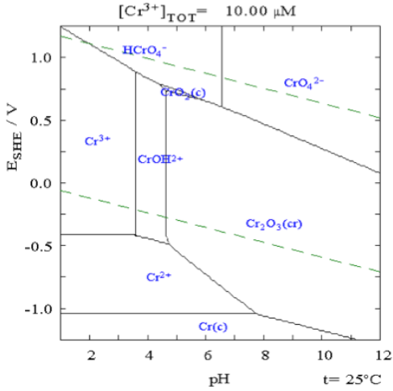Cr3+ lies on the far-left side of the Pourbaix diagram (Fig. 8) and is the only form of Cr stable at low pH in water. Therefore, we expect that anything oxidized in acidic conditions, regardless of starting oxidation state, will become Cr3+. The forms of Cr stable in basic conditions are Cr3+ in the form of Cr2O3 and Cr6+ in the form of CrO42-. We expect to only see the Cr6+ form when we react in basic conditions however, because the starting oxidation states in the compounds are +3 in Cr2(SO4)3, which will be oxidized to 6+ and +6 in K2CrO4, which cannot be oxidized above 6+. The results we see confirm these speculations. The spectrum for unreacted Cr2(SO4)3, which we know contains Cr3+, shows two peaks around 407 and 580 nm. We expected to see no change under acidic conditions as 3+ is the most stable state in acidic conditions, and indeed the Cr2(SO4)3 acidic spectrum peaks around 407 and 580 nm. We do expect to see a shift under basic conditions. We find that there is a shift in the base spectrum, with a new λmax at 373 nm. When we compare this to the spectrum of unreacted K2CrO4, which we know contains Cr6+, we see a peak around the same wavelength (373 nm), confirming Cr2(SO4)3 oxidized under basic conditions results in a Cr6+ oxidation state. Continuing to examine the K2CrO4 spectrum, we expect that under acidic conditions, the spectrum should look like a Cr3+ spectrum, and indeed it does with peaks at 419.0 and 591.0 nm. Finally, we observe that under basic conditions, the absorption does not change relative to the unreacted K2CrO4­, with a peak at 373 nm, indicating the Cr6+ oxidation state as precited.

Figure 8: Pourbaix diagram for Cr at 25°C

The oxidation of chromium(III) sulfate in acidic conditions

The reduction of potassium chromate in basic conditions

Conclusion

References

1. <https://www.csudh.edu/oliver/chemdata/data-e.htm>
2. Skoog, D.A., Holler, F.J., Crouch, S.R. Principles of Instrumental Analysis, 6th ed.; Brooks/Cole, 2007; p 375.
3. Cotton, F. Albert, Lee M. Daniels, Elizabeth A. Hillard, and Carlos A. Murillo. "The Lengths of Molybdenum to Molybdenum Quadruple Bonds: Correlations, Explanations, and Corrections." Inorganic Chemistry 41.9 (2002): 2466-470. Web.
4. Mcgrady, John E. "Electronic Structure of Metal-Metal Bonds." Encyclopedia of Inorganic and Bioinorganic Chemistry (2011): Web.

1. https://www.csudh.edu/oliver/chemdata/data-e.htm